Subproject_4_nlp
EDA analysis of cyber attack server logs (TCP header analysis)
1. Class Distribution Analysis
The initial bar graph highlights a significant class imbalance in the dataset. The number of benign samples is greater than the number of malicious ones. This disparity may impact model performance, particularly in terms of accuracy, recall, and the detection of minority-class events.
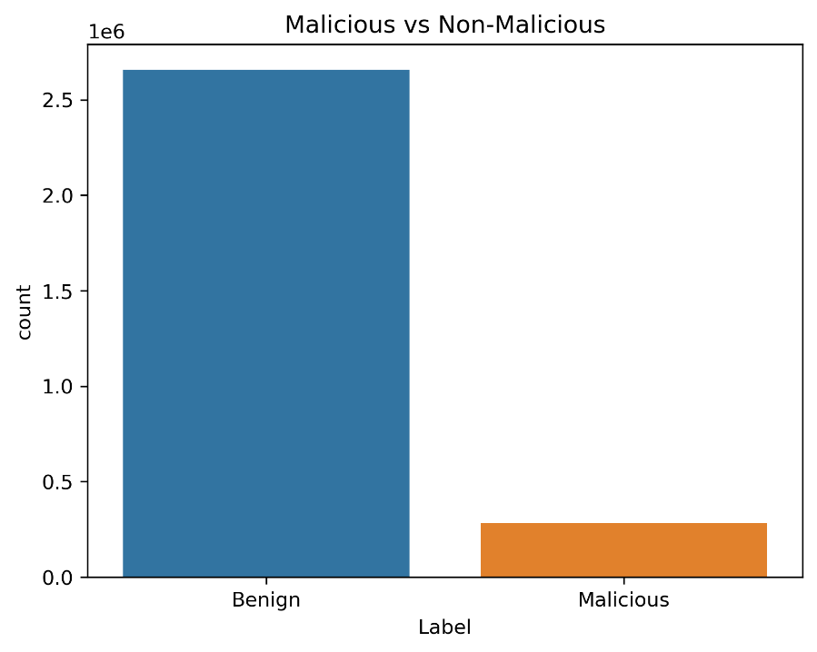
Further analysis of attack types reveals that Denial of Service (DoS) attacks—specifically DoS-GoldenEye and DoS-Slowloris—dominate the malicious samples. The dataset contains very few instances of SQL Injection and Infiltration attacks. Overall, malicious payloads constitute only 9.6% of the entire dataset, reinforcing the imbalance issue.
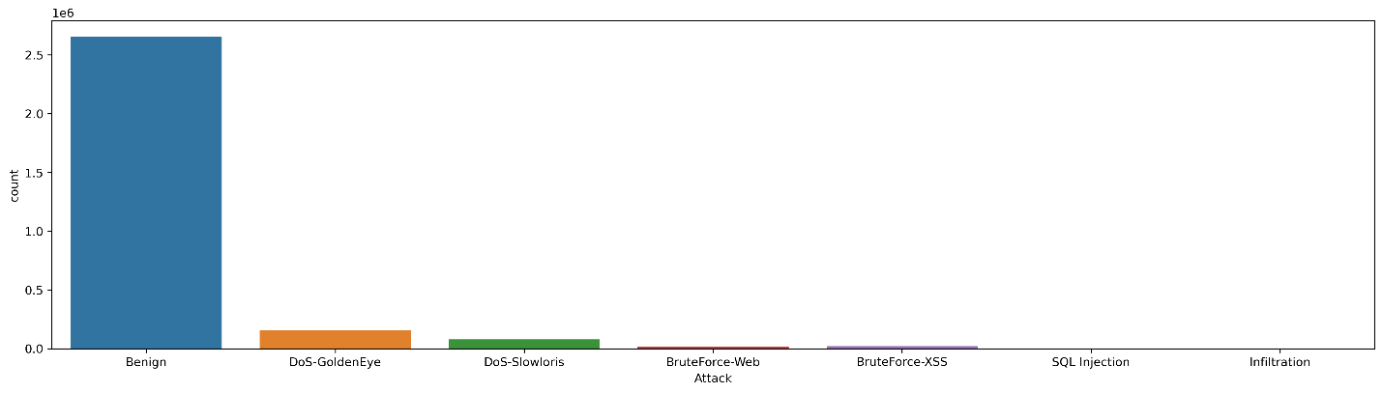

2. Entropy Feature Correlation Analysis
To understand patterns in the distribution of payload entropy, I evaluated the correlation among entropy features across the entire dataset.
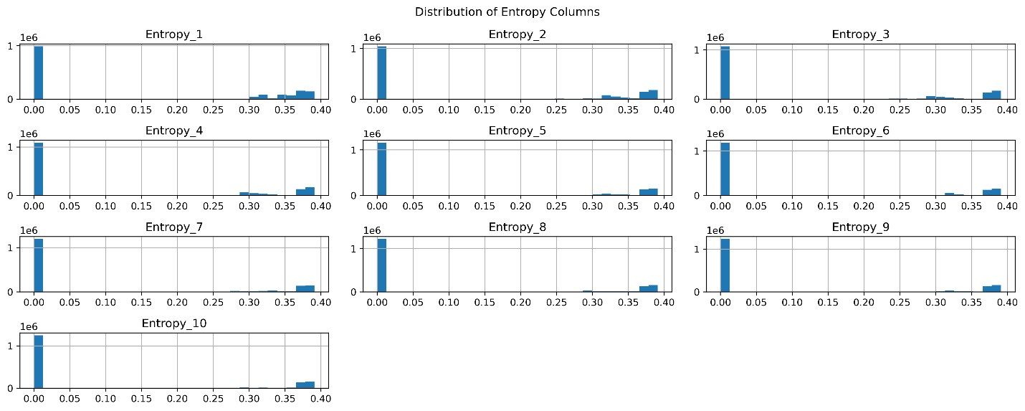
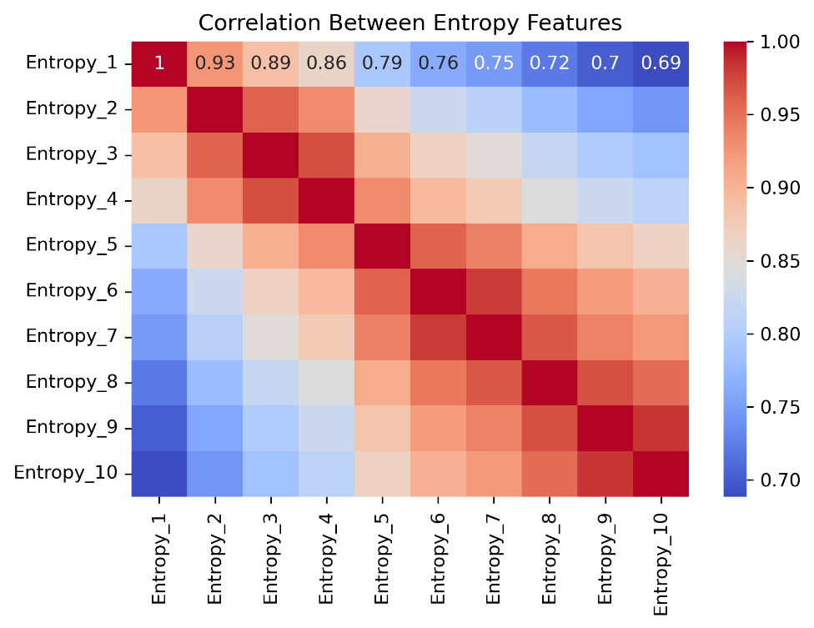
- All entropy-related columns exhibit positive correlation with each other.
- The first 10% and second 10% of the payload show a moderately strong correlation.
- The latter segments of the payload (last 40%) demonstrate medium to strong correlations among themselves, suggesting potential redundancy or consistency in entropy structure.
3. Entropy Correlation in Malicious Payloads
Focusing exclusively on malicious samples, I observed the following patterns:
- The first four entropy segments show near-perfect correlation. This indicates a strong similarity in the entropy ranges of the first 40% of malicious payloads, implying that malicious data often embeds attack patterns early in the payload.
- The correlation strength gradually decreases across the subsequent entropy segments, suggesting less consistency in entropy distribution in the latter parts of the payload.
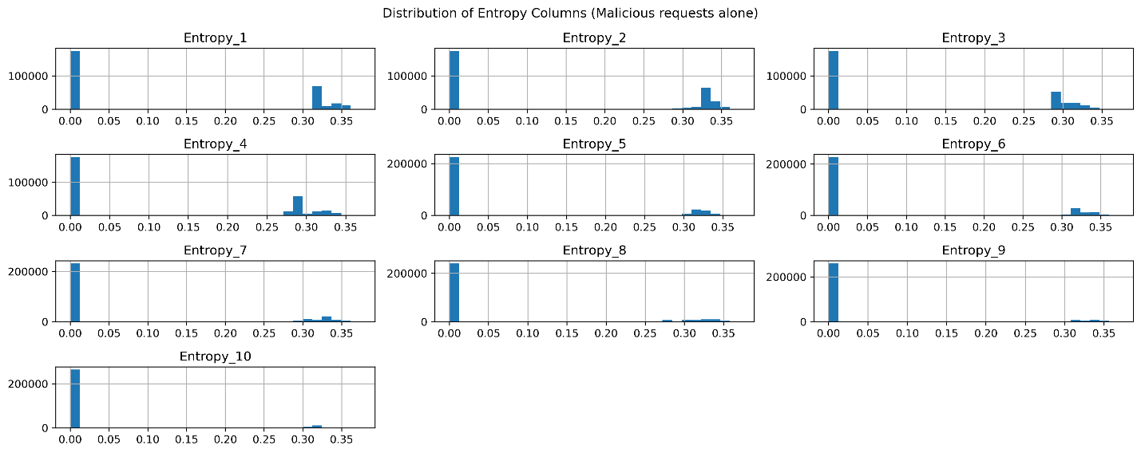
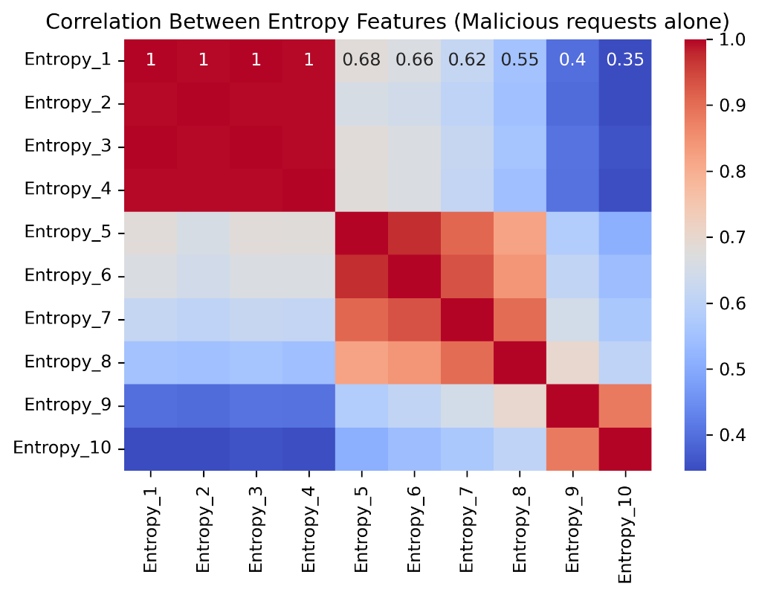
4. Header Bit Analysis
I examined the Header_Bit columns to identify patterns specific to malicious traffic.
- The bits with the highest activity overall are: 2, 4, 29, 50, 78, 79, 108, 114, and 124.
- Malicious payloads consistently show activity in specific header bits, indicating that certain bit patterns may be indicative of attack signatures.
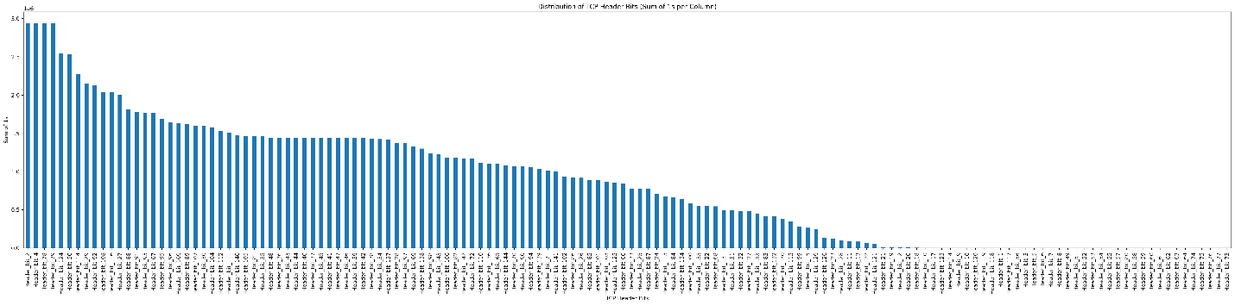
5. Word Cloud Analysis
Text-based payload patterns offer further insight into the behavioral differences between benign and malicious samples.
- In benign payloads, common terms include "User-Agent", "NET", and "CLR", suggesting normal browser or client software signatures.
- In malicious payloads, references to "User-Agent" are largely absent. Instead, the payloads include server-related identifiers such as "Apache" and "Ubuntu", which may point to automated scripts or server-side attacks.
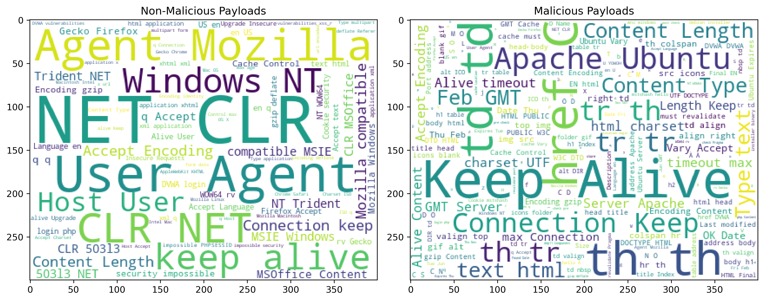

Conclusion
This exploratory data analysis reveals key distinctions between benign and malicious payloads. The imbalance in class distribution, strong entropy correlations, distinct header bit patterns, and divergent textual content provide valuable signals for designing robust classification models. Addressing class imbalance and emphasizing high-variance features will be crucial in the next stages of modeling and feature engineering.

